Servers🡪Policies-🡪 Root-🡪Host Firmware Package--🡪Default-🡪 Modify Package Version

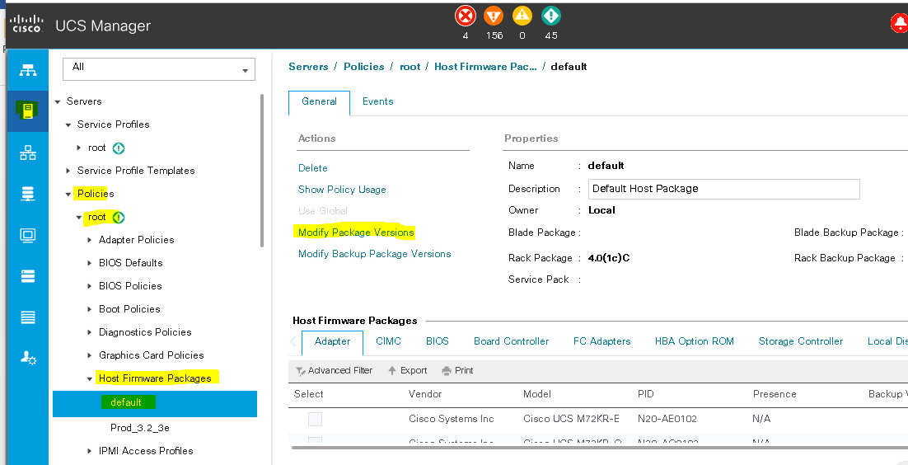

Uncheck Local Disks if check mark is there from Excluded Components

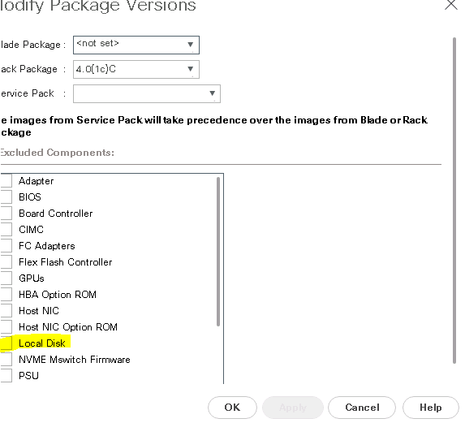

Now check service profile Template

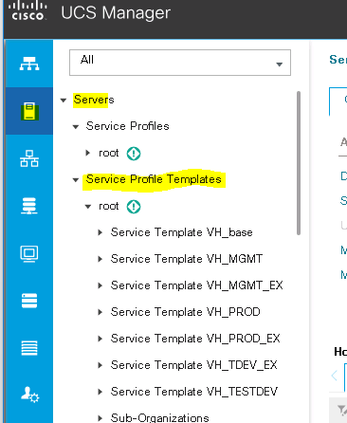

Check show policy usage to know how many servers are being used service profile template.

Service template🡪General🡪Show Policy Usage.

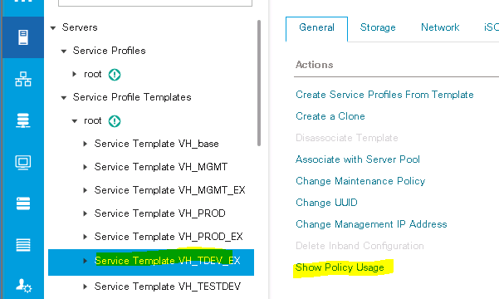

Make a note how many associated with desired Service profile Template

After you notified cancel this wizard.

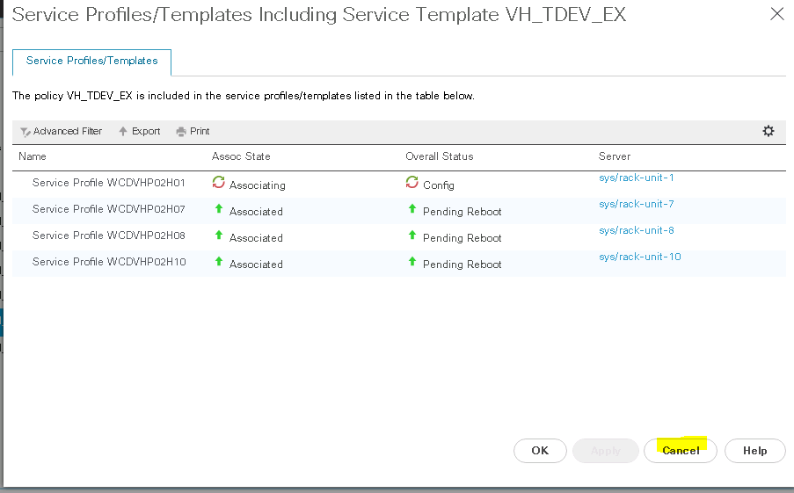

On used service profile templates select each service profile template

Policies🡪Firmware Policies🡪choose Default

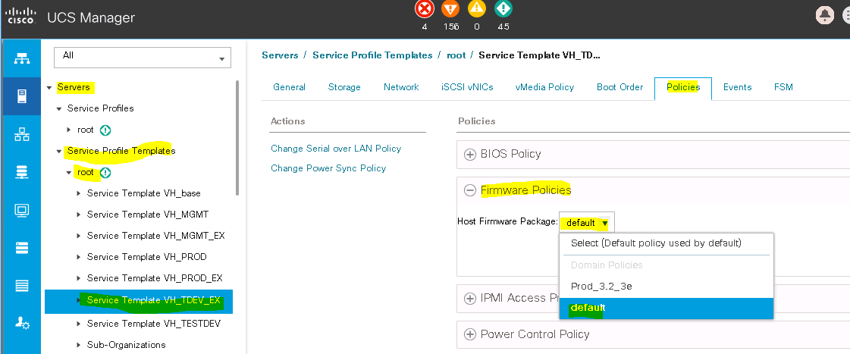

Once you changed servers will ask acknowledgement for pending reboot.

After install Infrastructure firmware, choose install server firmware. And complete the process.

Once it completed you are good to validate firmware version and HDD firmware.

Validating running version Firmware for disks and server firmware

